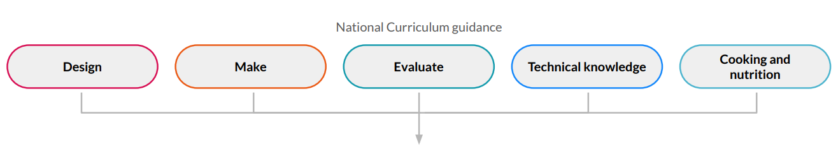


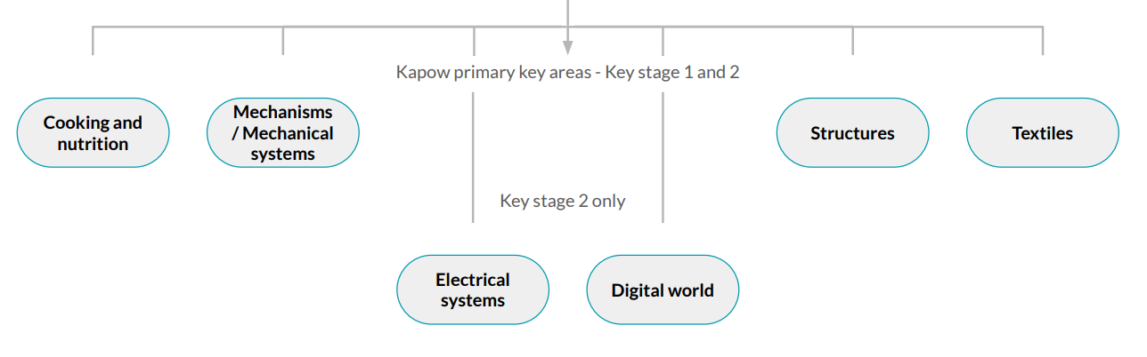
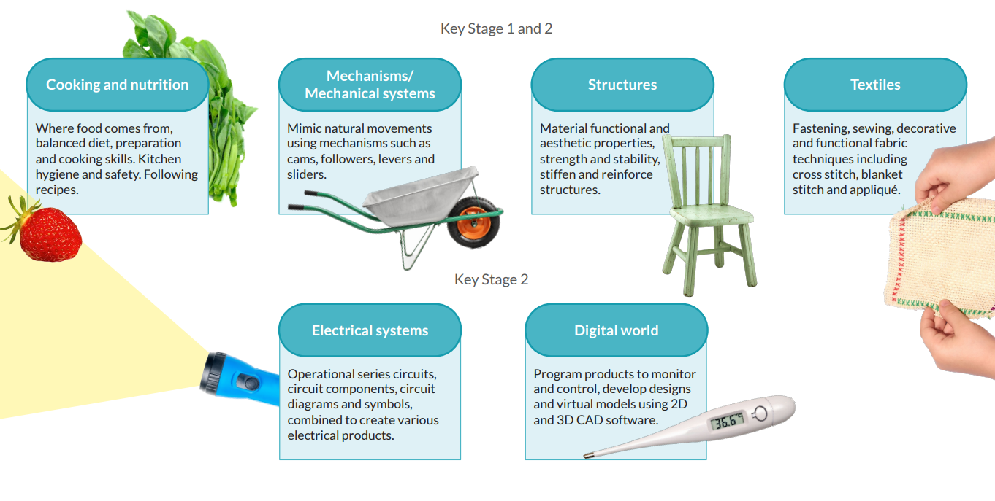
The six areas of learning revisited each year through a spiral curriculum building on each skill taught and learned. This structure will assist teachers to understand and implement prior and future learning regarding this subject.

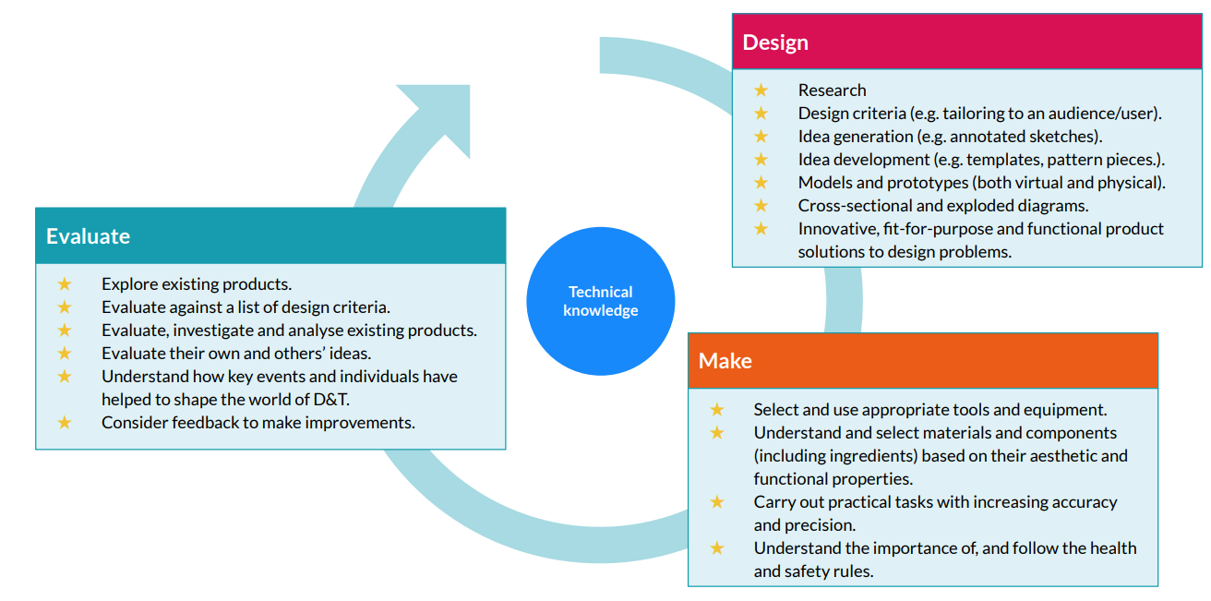
The National Curriculum for Design and Technology outlines three main stages of the design process, each unit follows these stages to create a full project. Cooking and Nutrition has a separate section in the national curriculum focusing on skills and technique in foods, diet and nutrition and seasonality of certain foods. Creating recipes for specific requirements incorporating the design criteria, as well as packaging food and displaying nutritional information.
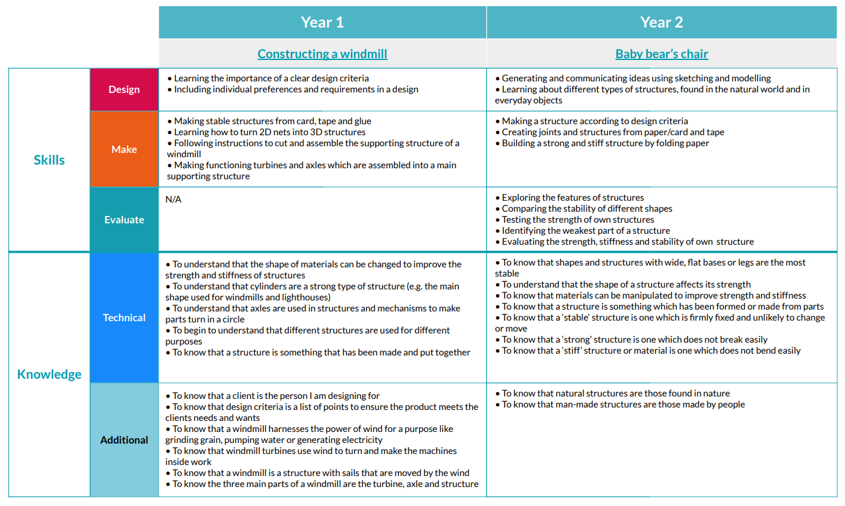
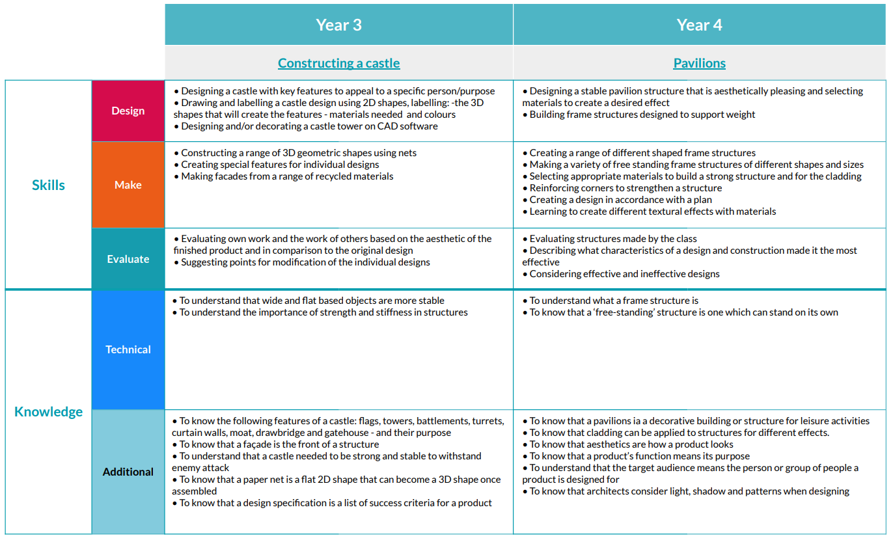
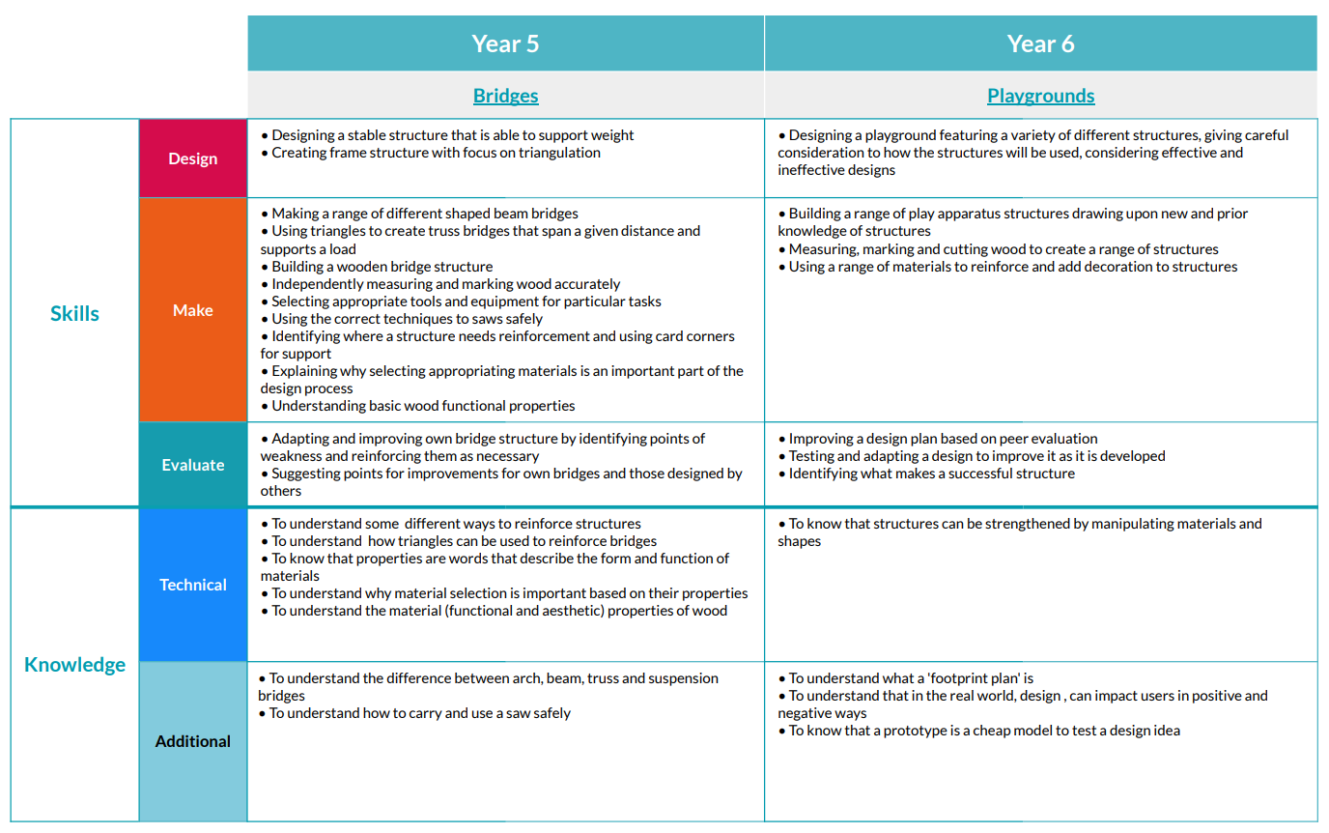

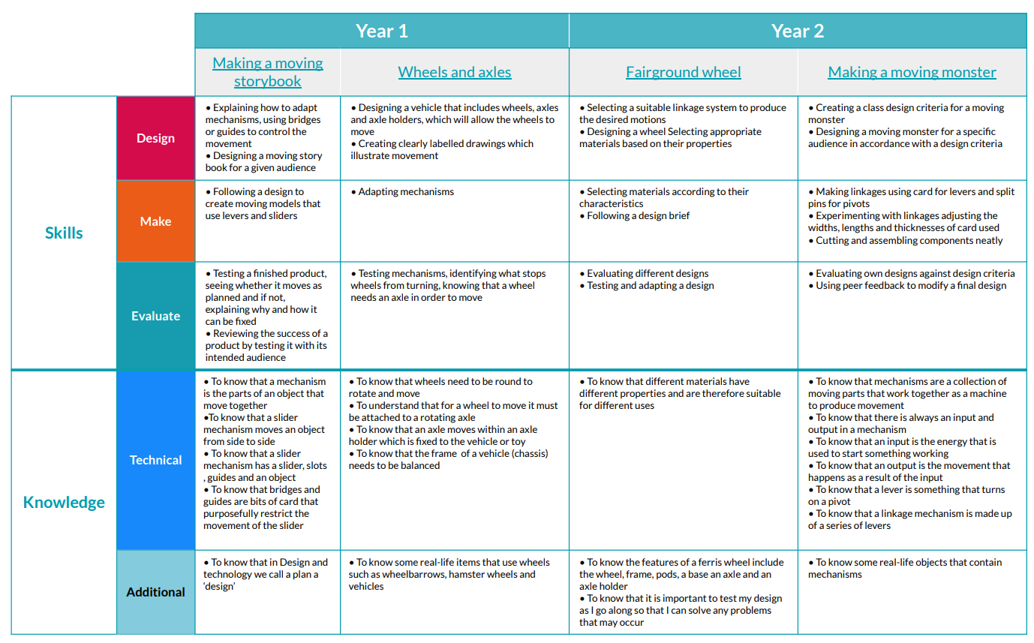

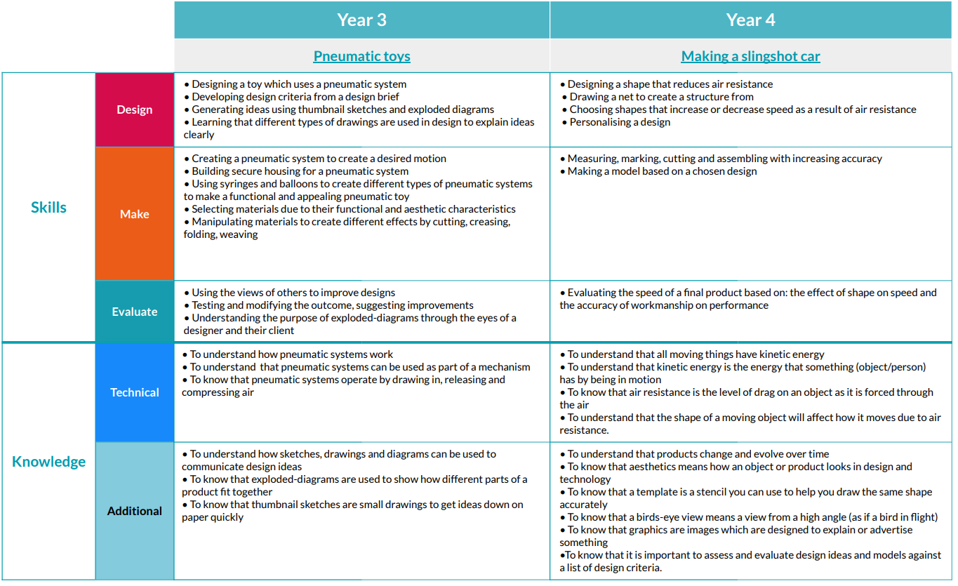

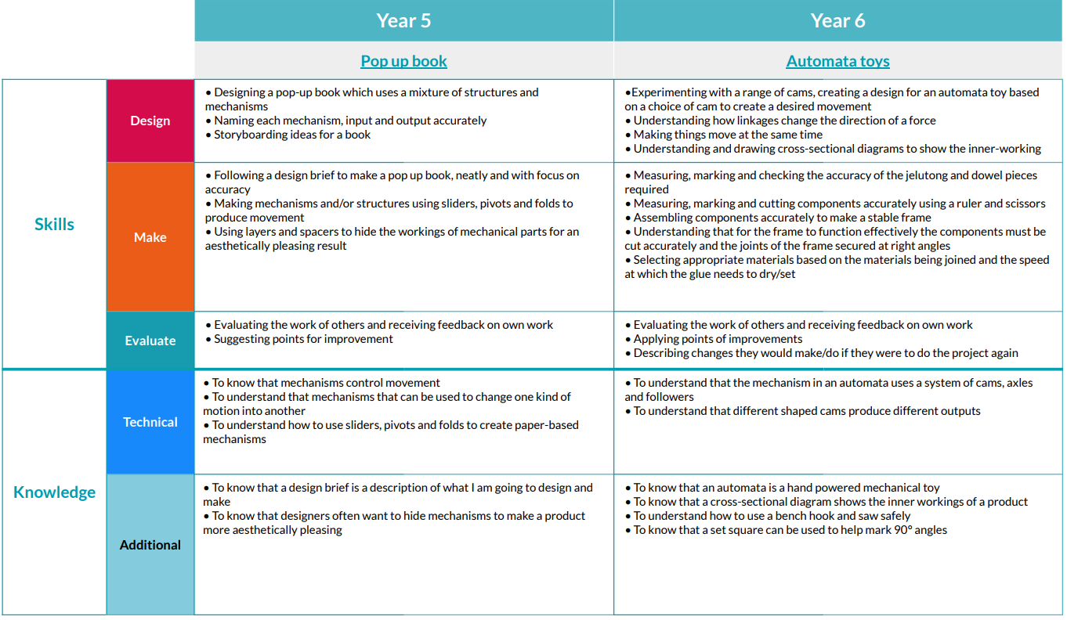

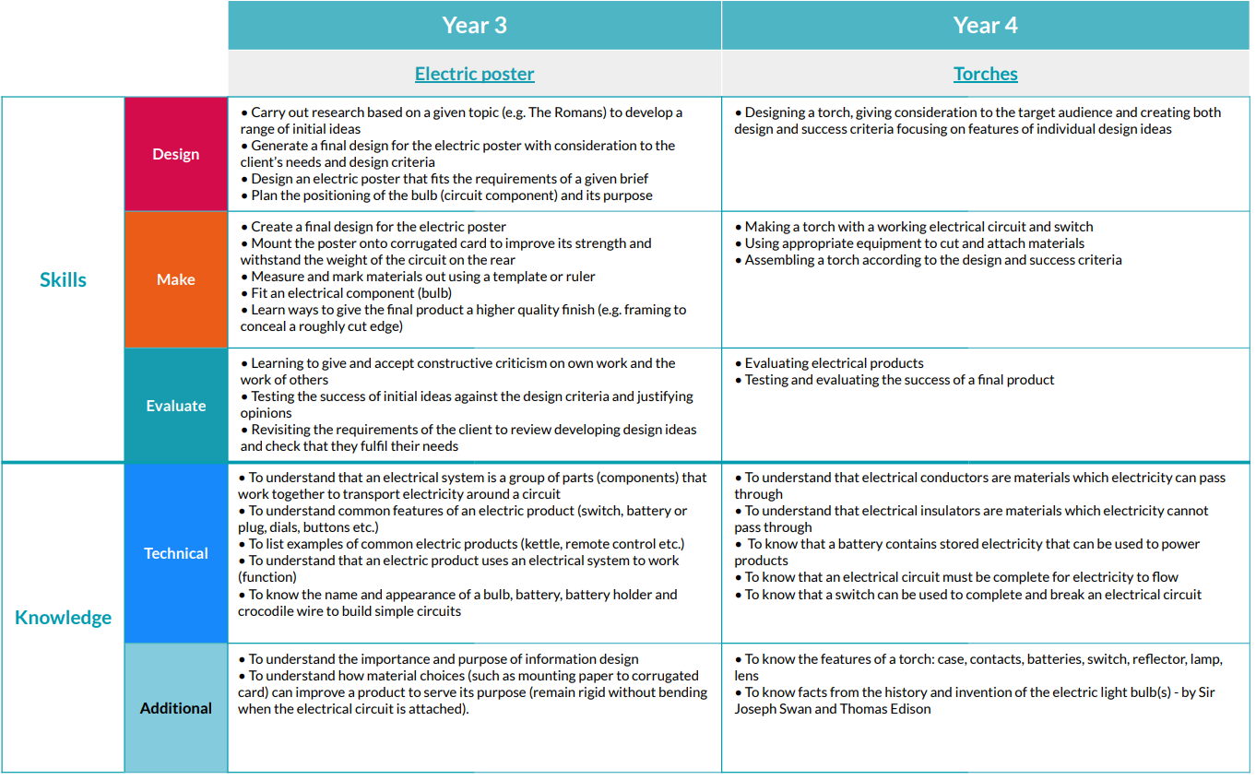

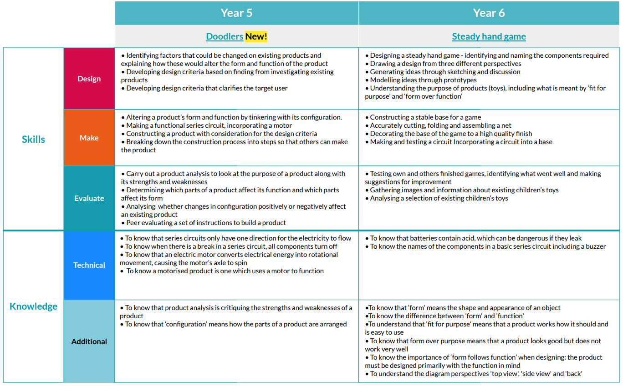



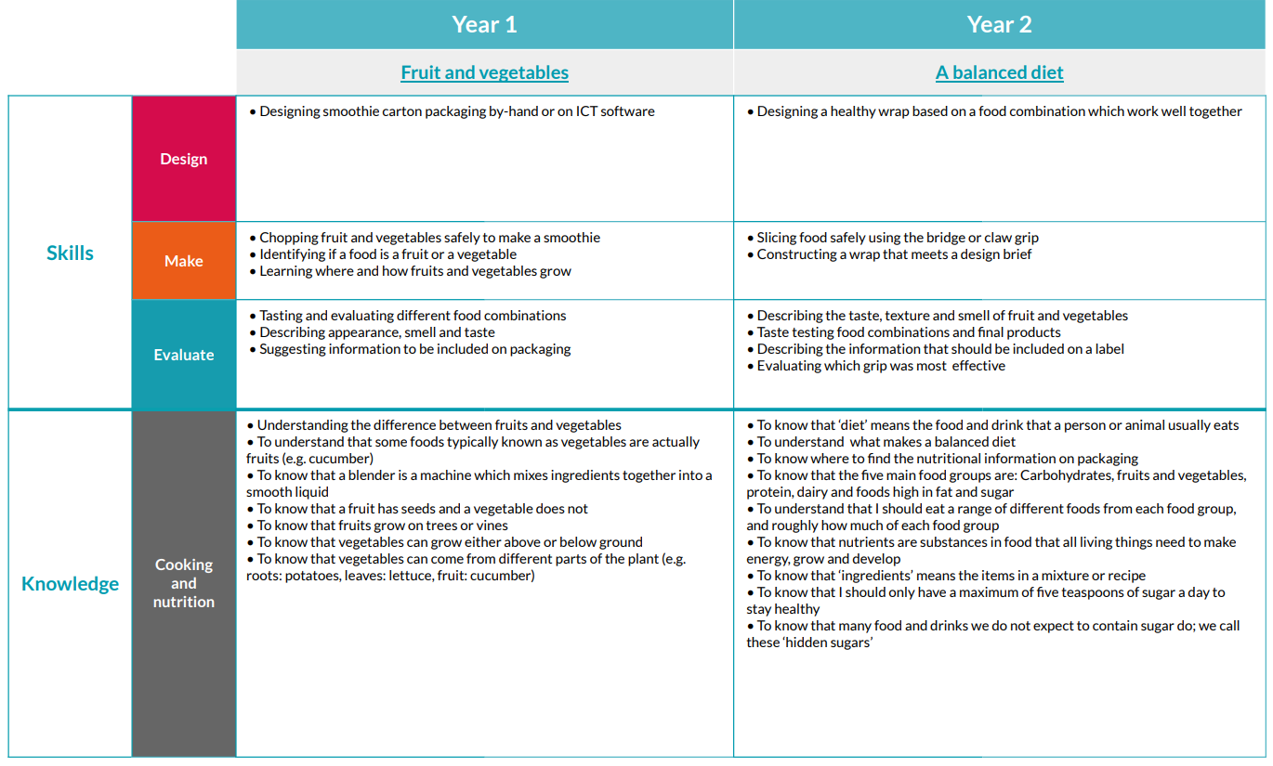

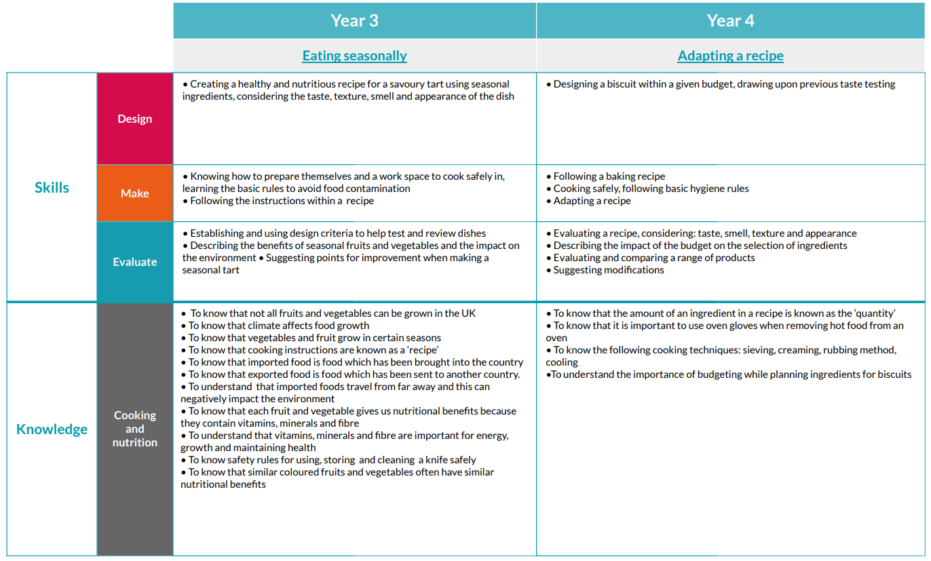

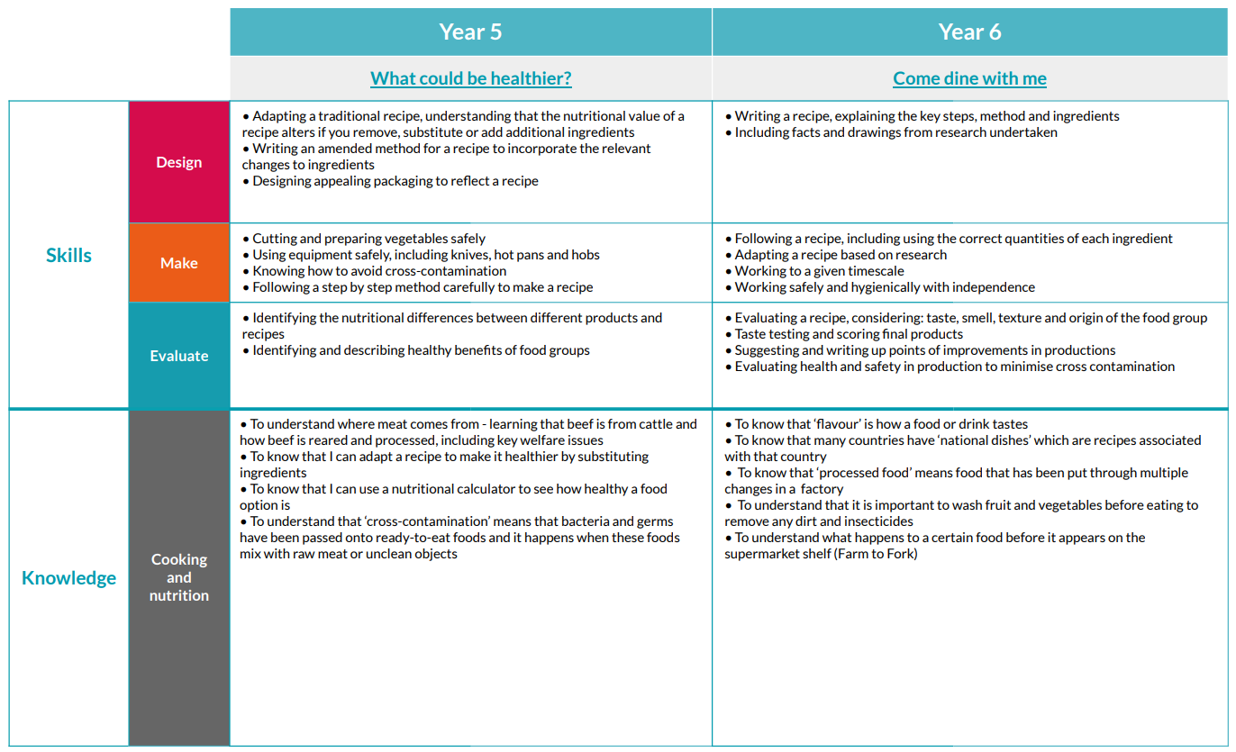

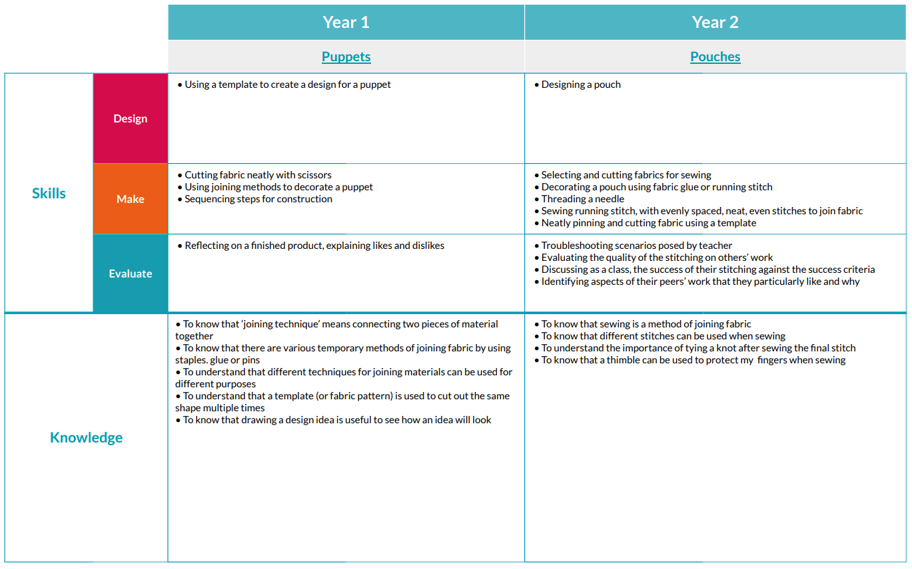

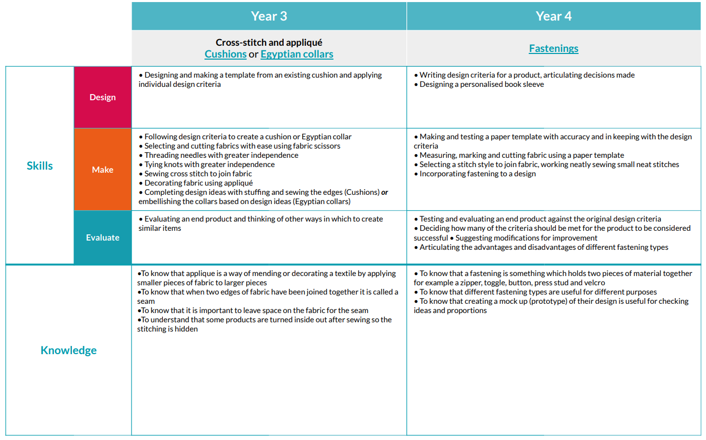

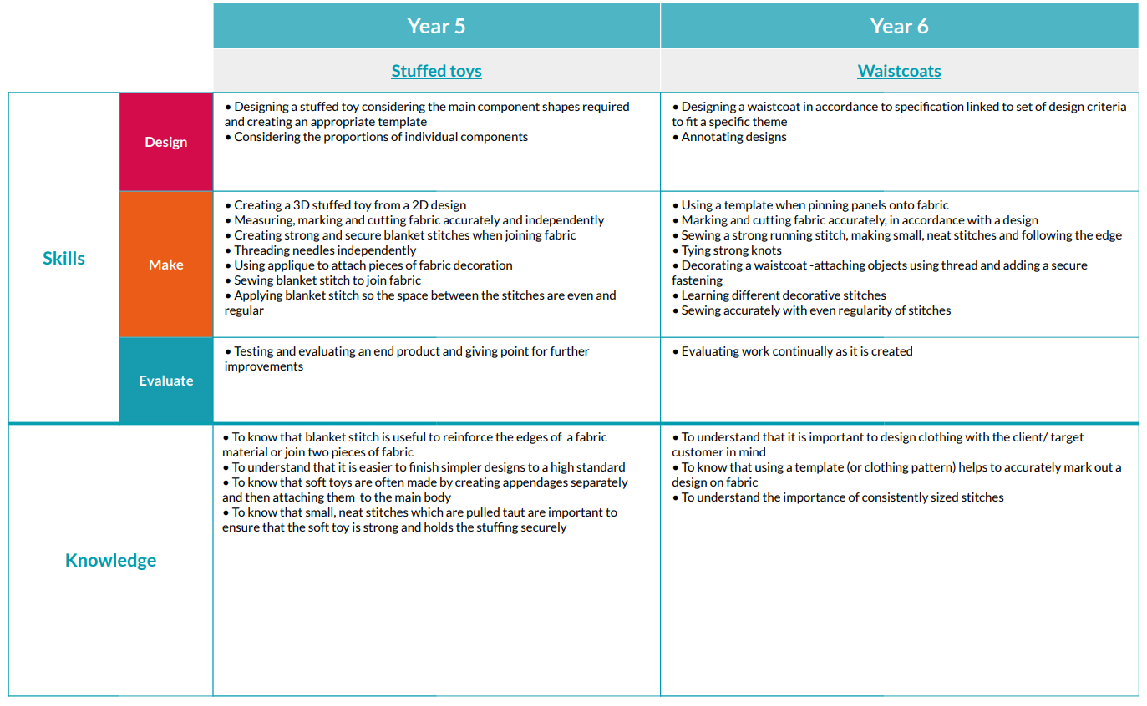

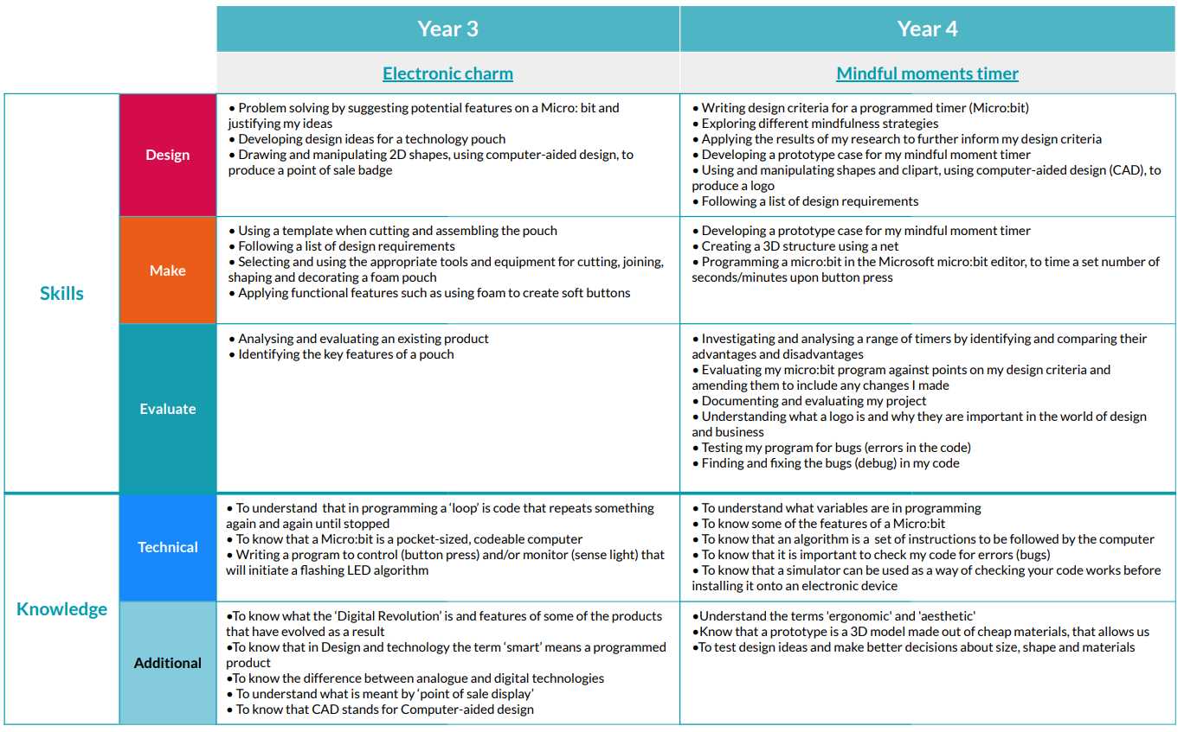

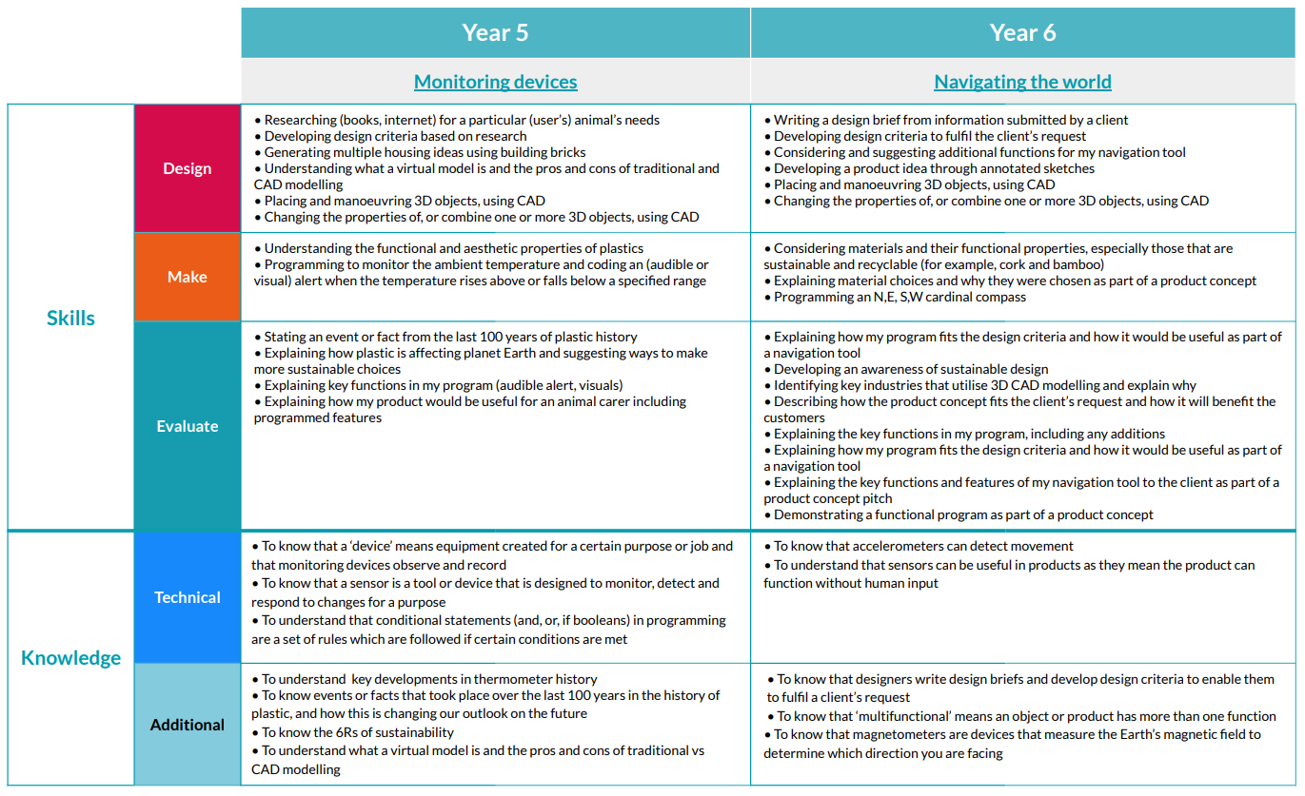

 | Autumn 1 | Autumn 2 | Spring 1 | Spring 2 | Summer 1 | Summer 2
EYFS | Structures | Mechanisms | Textiles  Thread stitching | Food  Tasting | Structures
Year 1 | Structures  Constructing a windmill | Mechanisms  Making a moving story book | Textiles  Puppets | Food  Fruits and Vegetables | Mechanisms  Wheels and axels
Year 2 | Structures  Constructing a chair | Mechanisms  Making a fairground wheel | Textiles  Pouches | Food  Balanced diet | Mechanisms  Make a moving monster
Year 3 | Structures  Constructing a castle | Mechanical Systems  Pneumatic toys | Textiles  Cushions or Egyptian collars | Food  Eating Seasonally | Digital world  Electronic Charm | Electronical Systems
Year 4 | Structures  Constructing a pavilion | Mechanical Systems  Making a sling shot car | Textiles  Fastenings | Food  Adapting a recipe | Digital world  Moments timer | Electronical Systems
Year 5 | Structures  Constructing a bridge | Mechanical Systems  Wheels and axels | Textiles  Designing a stuffed toy | Food  What could be healthier | Digital world  Monitoring devices | Electronical Systems
Year 6 | Structures  Constructing a playground | Mechanical Systems  Automata toys | Textiles  Waistcoats | Food  Come dine with me | Digital world  Navigating the world | Electronical Systems

