Ratified at the Full Governing Board meeting on _____________
Signed ________________
Due for review: Every two years

Northlands Primary School and Nursery
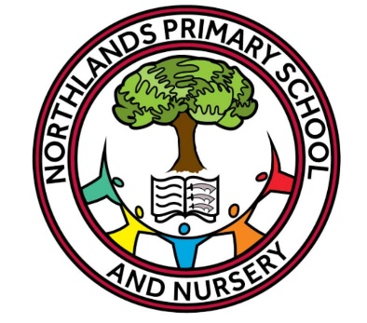
Geography Policy

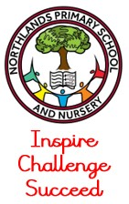
Northlands Primary School and Nursery
Policy for Geography
Curriculum Intent
Our school unlocks the potential within every child to inspire, challenge and succeed within in society.
At Northlands Primary School, we believe Geography stimulates children’s interests in their local area and develops an understanding of concepts, knowledge and skills. We seek to inspire in children a curiosity and fascination about the world and its people which will remain with them for the rest of their lives; to promote children’s sense of wonder at the beauty of the world around them.
Aims and Objectives
- Help children to develop an informed concern about the quality of the environment and the future of the human habitat.
- Enhance children’s sense of responsibility for the care of the Earth and its people.
- Develop a range of investigation and problem-solving skills which are transferable to other curriculum areas.

Support for pupils with additional needs
At Northlands, all children are provided with equal opportunities to access the geography curriculum. Children are provided with engaging resources and information at an appropriate level through a variety of teaching and learning styles. Adaptive teaching will be utilised by the class teacher so that pupils receive any necessary support to develop new keys skills and understand the unit being taught.

Internet Safety
Internet access is planned to enrich and extend learning activities across the curriculum. However, we have acknowledged the need to ensure that all pupils are responsible and safe users of the Internet and other communication technologies both in school and outside. The Internet is used in Geography lessons as a tool to explore the physical geography of the world and adults ensure that all material is age-appropriate.

The Early Years Foundation Stage
In Nursery and EYFS, children are exposed to knowledge and understanding of the world through play giving them the tools they need to meet their Early Learning Goals as outlined in the Early Years Foundation Stage Framework (2021). This approach allows children to start exploring geographical skills which they can apply to their understanding of the world.

Geography Curriculum
At Northlands, we offer a broad and balanced curriculum to develop children’s geographical skills and field work. This is taught as explicit geography skill lessons and through big question led enquiries about topics, places and themes allowing them sufficient scope and time to really engage in high order subject skills. We teach geography at least once a week, in every class for a minimum of 30 minutes implementing an understanding of key geographical vocabulary and facts. Lessons are carefully planned to ensure that there is always a balance between new content and development of important subject skills and the ability of children to think critically about what they are learning and why. Lessons are linked to the chosen topics for each year group. There is a progression of skills across the school which enables children to focus on geographical questions like What is it like? How did it get like this? How and why is it changing? And to develop and use geographical enquiry skills, geographical terms and making and using maps.

Assessment
Assessment of children’s progress is made informally over a period of time. This may include observing pupils work, involving children in peer assessing, questioning, talking, and listening to pupils and considering materials produced by the children. A minimum of 1 piece of Geography work in Topic books per half term focused on a key geographical skill incorporating geographical vocabulary through a challenge question. Progress is reported to parents by annual reports.

Linked policies / documents:
Curriculum intent

